**Task4 – 1017 – Vuppala Likitha**

**1.using Google Dorks**

**a.find out the faculty list of your clg.**

**b.find the similar websites related to sans.com**

**a.** 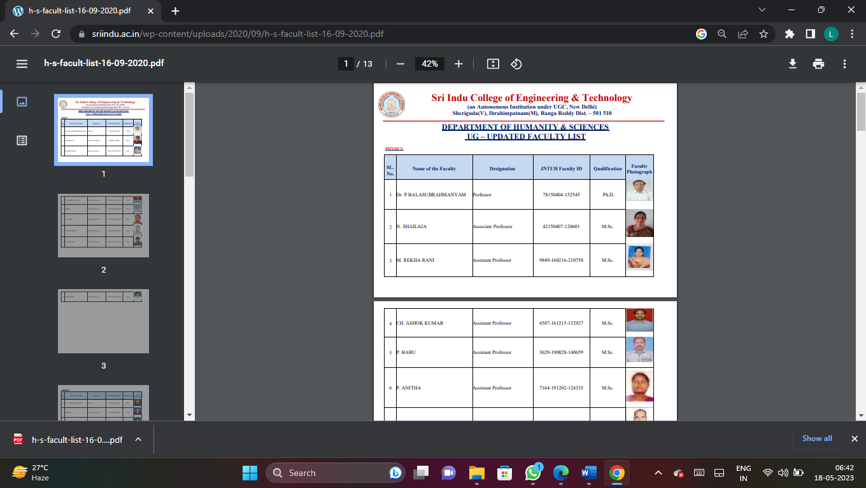

**b. giac.org**

cisecurity.org

isaca.org

eccouncil.org

blackhat.com

itsecurity.com

securityteam.com

**2.find the channel Id of EC-council youtube channel using mattw.io**

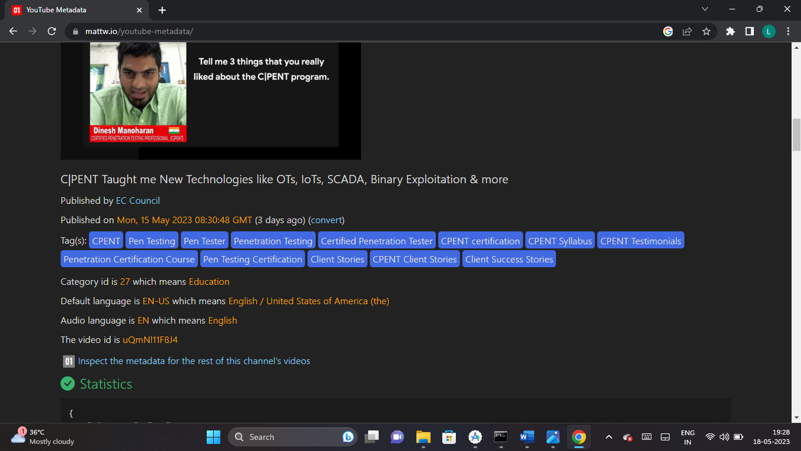

**3.find the sub-domains of the following using the Netcraft**

**a.Microsoft.com**

**b.sans.org**

**c.your college**

**a.Microsoft.com :-**

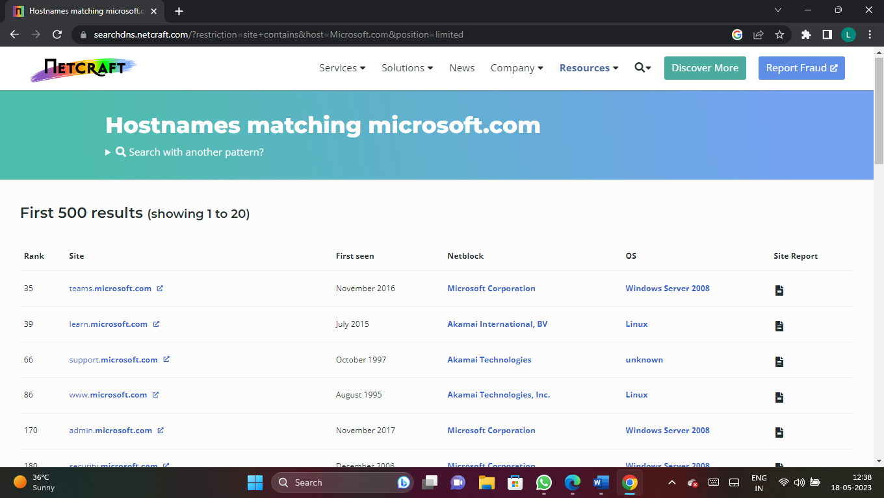

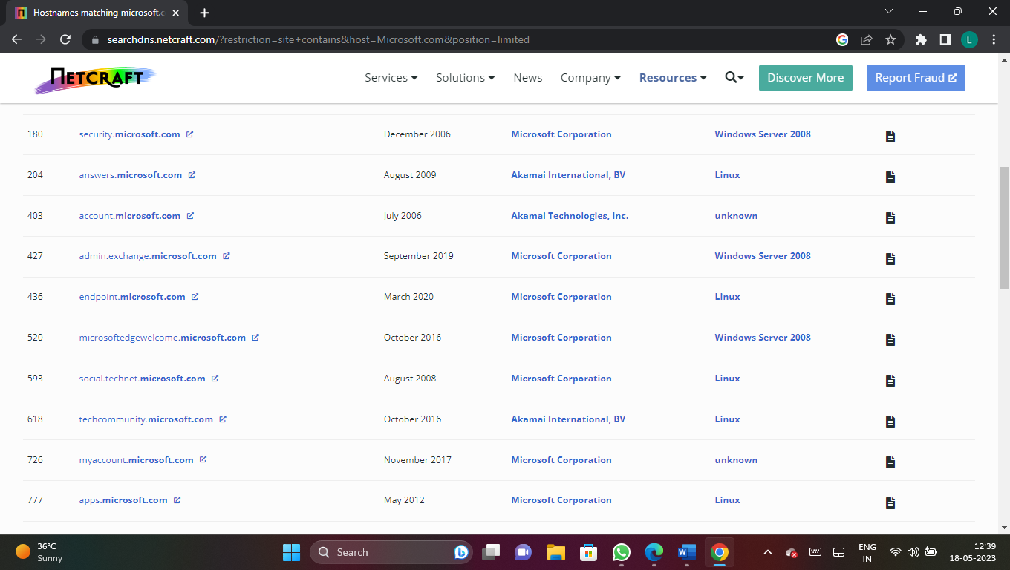

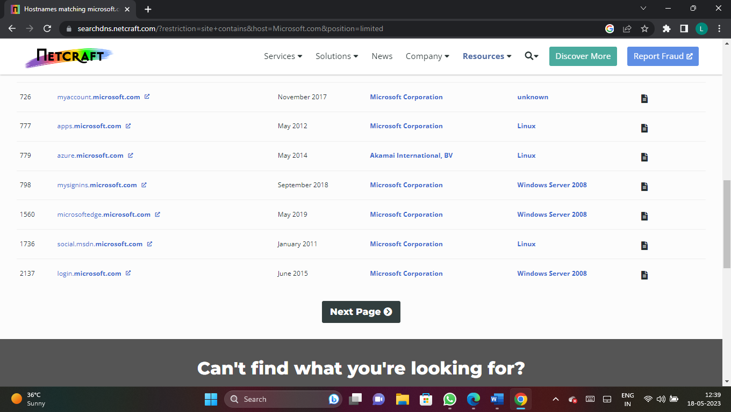

**b.sans.org:-**

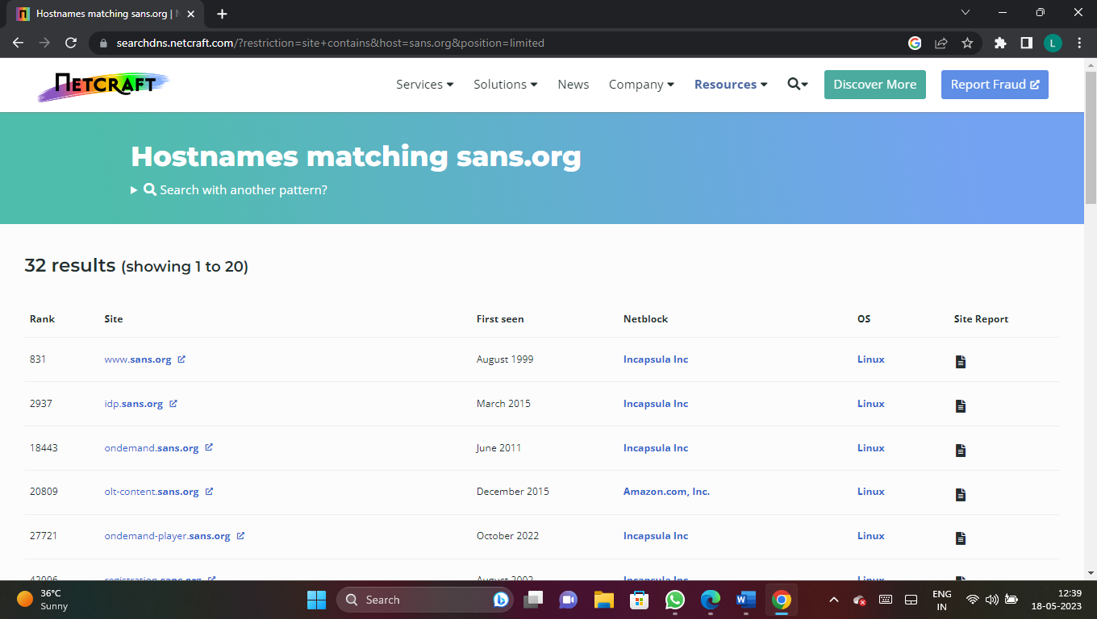

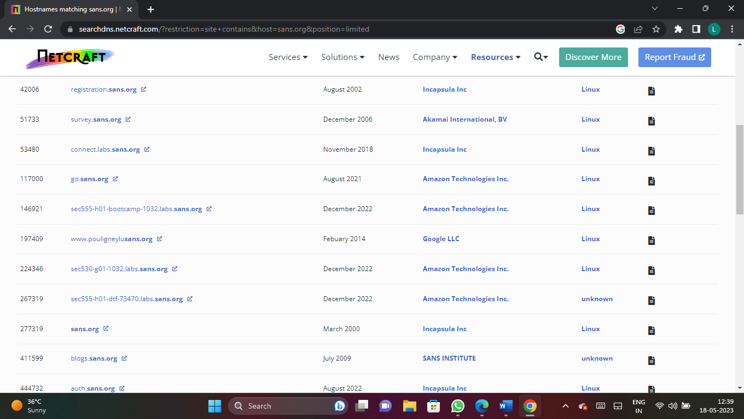

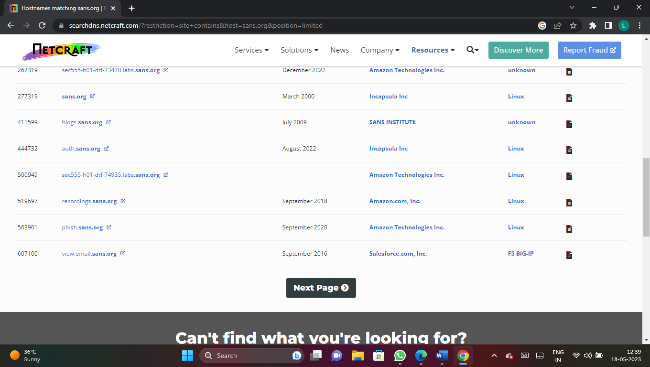

**c.your college:-** 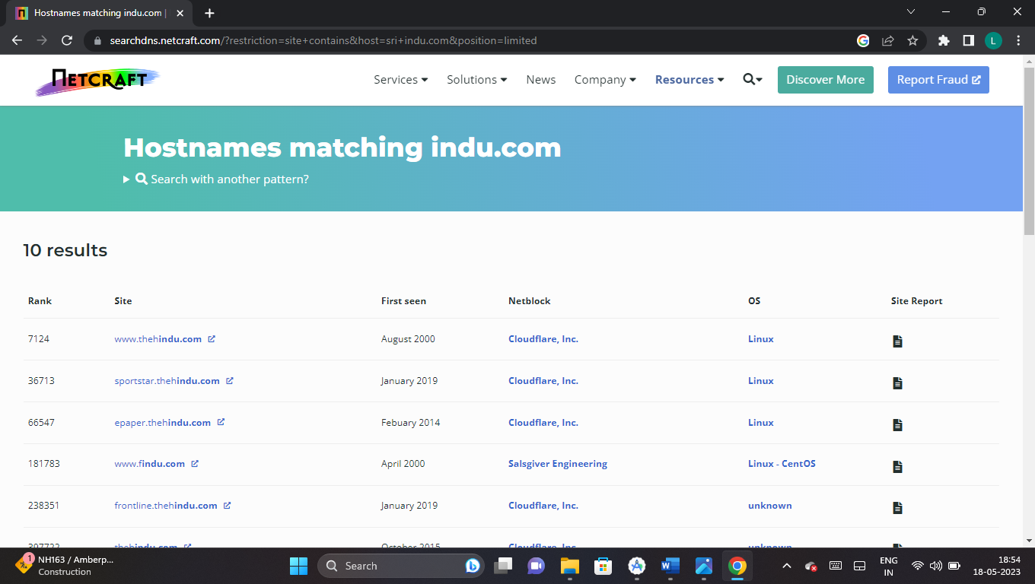

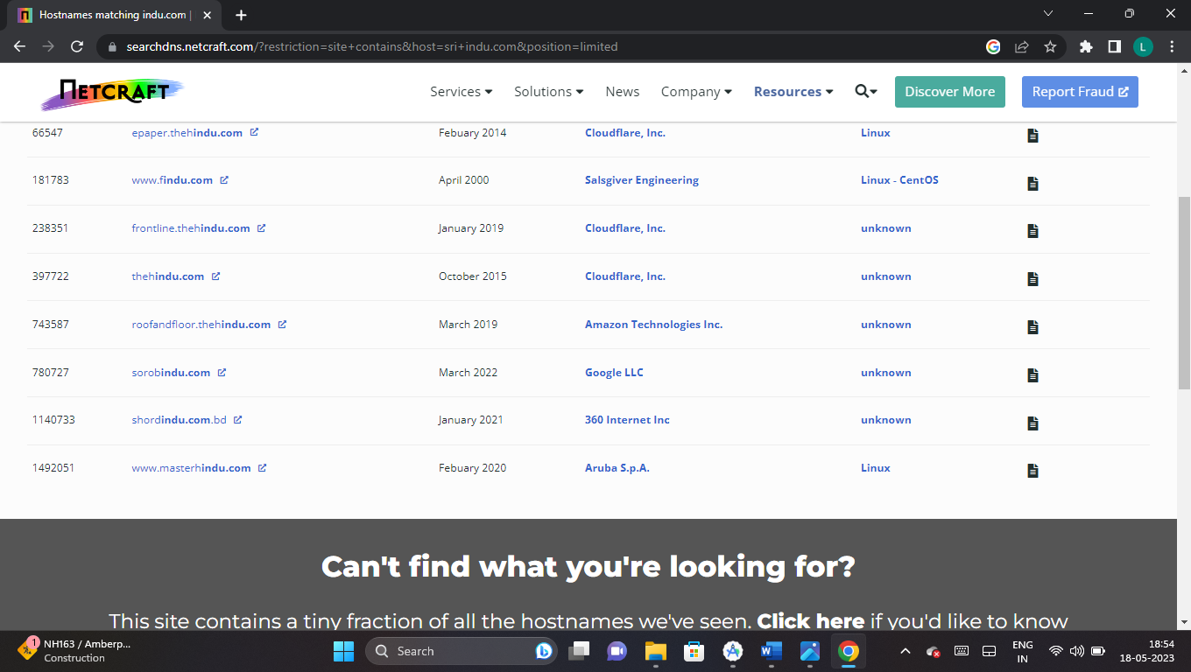

**d.Gradespot academy:-** 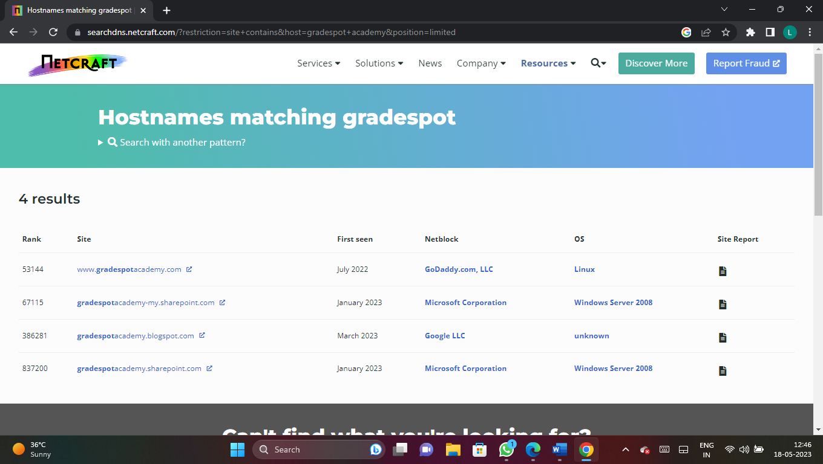

**4.Find out IP Address of the following targets,using PING command line Utility**

**a.Eccouncil**

**b.Certifiedhacker.com**

**c.Yourcollege**

**d.Microsoft.com**

**e.sang.org**

**a.Eccouncil.org:-**

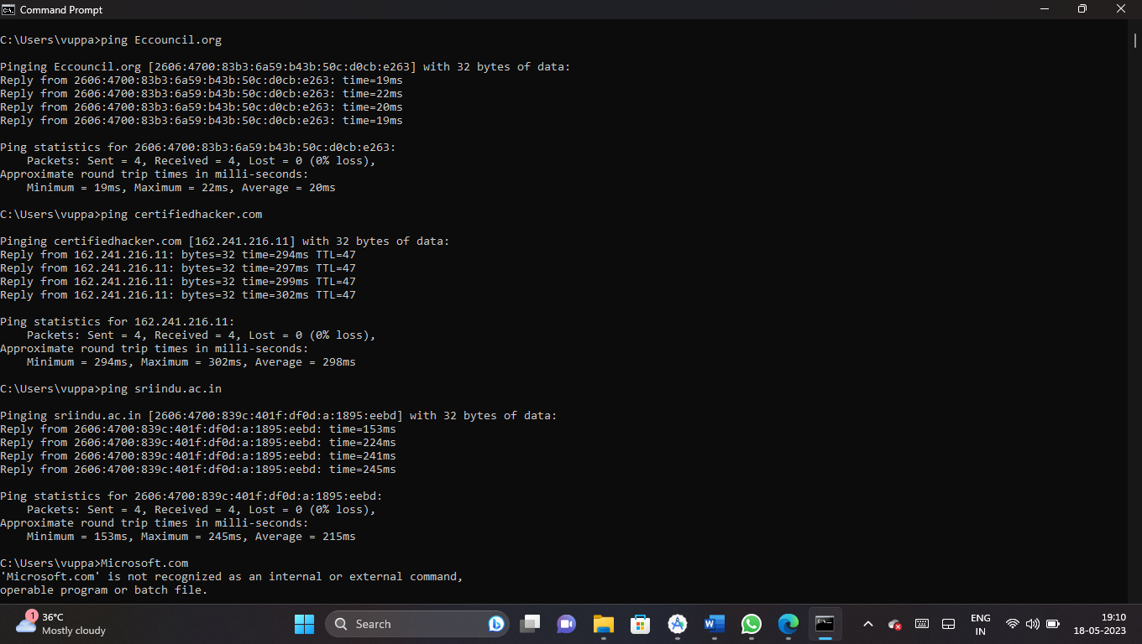

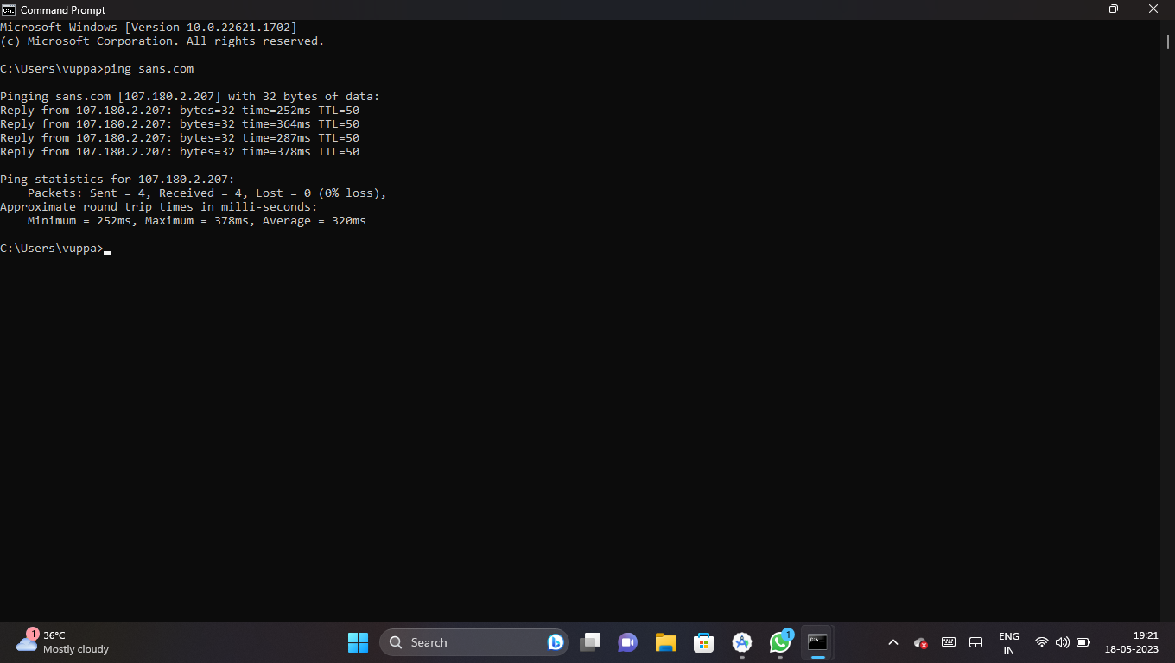

**5.clone** [**https://www.certifiedhacker.com**](https://www.certifiedhacker.com) **to your local machine using “HTTrack Web Copier”**

<head>

    <meta http-equiv="Content-Type" content="text/html; charset=utf-8" />

    <meta name="de<html xmlns="http://www.w3.org/1999/xhtml" lang="en">

scription" content="HTTrack is an easy-to-use website mirror utility. It allows you to download a World Wide website from the Internet to a local directory,building recursively all structures, getting html, images, and other files from the server to your computer. Links are rebuiltrelatively so that you can freely browse to the local site (works with any browser). You can mirror several sites together so that you can jump from one toanother. You can, also, update an existing mirror site, or resume an interrupted download. The robot is fully configurable, with an integrated help" />

    <meta name="keywords" content="httrack, HTTRACK, HTTrack, winhttrack, WINHTTRACK, WinHTTrack, offline browser, web mirror utility, aspirateur web, surf offline, web capture, www mirror utility, browse offline, local  site builder, website mirroring, aspirateur www, internet grabber, capture de site web, internet tool, hors connexion, unix, dos, windows 95, windows 98, solaris, ibm580, AIX 4.0, HTS, HTGet, web aspirator, web aspirateur, libre, GPL, GNU, free software" />

    <title>Local index - HTTrack Website Copier</title>

  <!-- Mirror and index made by HTTrack Website Copier/3.49-2 [XR&CO'2014] -->

    <style type="text/css">

    <!--

body {

    margin: 0;  padding: 0;  margin-bottom: 15px;  margin-top: 8px;

    background: #77b;

}

body, td {

    font: 14px "Trebuchet MS", Verdana, Arial, Helvetica, sans-serif;

    }

#subTitle {

    background: #000;  color: #fff;  padding: 4px;  font-weight: bold;

    }

#siteNavigation a, #siteNavigation .current {

    font-weight: bold;  color: #448;

    }

#siteNavigation a:link    { text-decoration: none; }

#siteNavigation a:visited { text-decoration: none; }

#siteNavigation .current { background-color: #ccd; }

#siteNavigation a:hover   { text-decoration: none;  background-color: #fff;  color: #000; }

#siteNavigation a:active  { text-decoration: none;  background-color: #ccc; }

a:link    { text-decoration: underline;  color: #00f; }

a:visited { text-decoration: underline;  color: #000; }

a:hover   { text-decoration: underline;  color: #c00; }

a:active  { text-decoration: underline; }

#pageContent {

    clear: both;

    border-bottom: 6px solid #000;

    padding: 10px;  padding-top: 20px;

    line-height: 1.65em;

    background-image: url(backblue.gif);

    background-repeat: no-repeat;

    background-position: top right;

    }

#pageContent, #siteNavigation {

    background-color: #ccd;

    }

.imgLeft  { float: left;   margin-right: 10px;  margin-bottom: 10px; }

.imgRight { float: right;  margin-left: 10px;   margin-bottom: 10px; }

hr { height: 1px;  color: #000;  background-color: #000;  margin-bottom: 15px; }

h1 { margin: 0;  font-weight: bold;  font-size: 2em; }

h2 { margin: 0;  font-weight: bold;  font-size: 1.6em; }

h3 { margin: 0;  font-weight: bold;  font-size: 1.3em; }

h4 { margin: 0;  font-weight: bold;  font-size: 1.18em; }

.blak { background-color: #000; }

.hide { display: none; }

.tableWidth { min-width: 400px; }

.tblRegular       { border-collapse: collapse; }

.tblRegular td    { padding: 6px;  background-image: url(fade.gif);  border: 2px solid #99c; }

.tblHeaderColor, .tblHeaderColor td { background: #99c; }

.tblNoBorder td   { border: 0; }

// -->

</style>

</head>

<table width="76%" border="0" align="center" cellspacing="0" cellpadding="3" class="tableWidth">

    <tr>

    <td id="subTitle">HTTrack Website Copier - Open Source offline browser</td>

    </tr>

</table>

<table width="76%" border="0" align="center" cellspacing="0" cellpadding="0" class="tableWidth">

<tr class="blak">

<td>

    <table width="100%" border="0" align="center" cellspacing="1" cellpadding="0">

    <tr>

    <td colspan="6">

        <table width="100%" border="0" align="center" cellspacing="0" cellpadding="10">

        <tr>

        <td id="pageContent">

<!-- ==================== End prologue ==================== -->

    <meta name="generator" content="HTTrack Website Copier/3.x">

    <TITLE>Local index - HTTrack</TITLE>

</HEAD>

<BODY>

<H1 ALIGN=Center>Index of locally available sites:</H1>

    <TABLE BORDER="0" WIDTH="100%" CELLSPACING="1" CELLPADDING="0">

        <TR>

            <TD BACKGROUND="fade.gif">

                &middot;

                    <A HREF="www.certifiedhacker.com/index.html">

                        www.certifiedhacker.com/index.html

                    </A>

            </TD>

        </TR>

    </TABLE>

    <BR>

    <BR>

    <BR>

    <H6 ALIGN="RIGHT">

    <I>Mirror and index made by HTTrack Website Copier [XR&amp;CO'2008]</I>

    </H6>

    <!-- Mirror and index made by HTTrack Website Copier/3.49-2 [XR&CO'2014] -->

    <!-- Thanks for using HTTrack Website Copier! -->

    <meta HTTP-EQUIV="Refresh" CONTENT="0; URL=www.certifiedhacker.com/index.html">

<!-- ==================== Start epilogue ==================== -->

        </td>

        </tr>

        </table>

    </td>

    </tr>

    </table>

</td>

</tr>

</table>

<table width="76%" border="0" align="center" valign="bottom" cellspacing="0" cellpadding="0">

    <tr>

    <td id="footer"><small>&copy; 2008 Xavier Roche & other contributors - Web Design: Leto Kauler.</small></td>

    </tr>

</table>

</body>

</html>

**6.Find the tools similar to “HTtrack Web Copier”**

### 1. [Cyotek Web Copy](https://www.cyotek.com/cyotek-webcopy" \t "_blank)

### 2. [GNUWget](https://www.gnu.org/software/wget/manual/wget.html" \t "_blank)

### 3. [Local Website Archive](https://www.aignes.com/lwa.htm)

### 4. [Mozilla Archive Format](https://addons.thunderbird.net/id/seamonkey/addon/mozilla-archive-format/?src=cb-dl-popular?src=cb-dl-popular)

### 5. [Ncollector Studio](https://download.cnet.com/NCollector-Studio/3000-2377_4-75165440.html" \t "_blank)

### 6. [Page Nest](https://www.malavida.com/en/soft/pagenest/)

### 7. [SiteSucker](https://ricks-apps.com/osx/sitesucker/index.html" \t "_blank)